
School of Information Technology and Engineering
Nov 2015

TITLE OF THE PROJECT
Open Source Content Management System with MVC for Electronic Commerce using PHP

MINI Project Report
Submitted in partial fulfilment for the award of the degree of

- P.Kiranmai 12MSE0006
- Sahana Mohan 12MSE0308

Table of Contents
ABSTRACT vii
List of Figures viii
LIST OF Abbreviations ix
1. INTRODUCTION 1
2. LITERATURE SURVEY 2
2.1 The Research of PHP Development Framework Based on MVC Pattern, 2
2.2WFCMS: An excellent web content management system, 2
2.3 Service level agreement framework for e-commerce cloud end-user perspective 3
2.4 The Saudi Recycling eCommerce Framework 4
2.5 The Research of PHP Development Framework Based on MVC Pattern 5
2.6 Improving protection of PHP source code using cryptology models 6
2.7 Enhancing Mysql Injector vulnerability checker tool (Mysql Injector) using inference binary search algorithm for blind timing-based attack 7
2.8 A Framework for Detecting Program Security Vulnerability Exploitations 8
2.9 Server Side Detection of Content Sniffing Attacks 9
2.10 A secure e-transaction model for e-commerce 10
2.11 Study on Security Based on PKI for E-commerce of Statistics Information System 11
2.12 Building Robust Authentication Systems With Activity-Based Personal Questions 12
2.13 Understanding a Complex Innovation Process: Identity Management in Austrian E-Government 13
2.15 E-Commerce Today and Tomorrow: A Truly Generalized and Active Framework for the Definition of Electronic Commerce 15
2.16 How Does Personality Affect Trust in B2C e-Commerce? 16
3. SYSTEM DESIGN 17
3.1 System Architecture 17
3.2 Data Flow Diagram 18
3.3 Activity Diagram 19
3.4 Class Diagram 20
3.5 Usecase Diagram 21
3.6 Sequence Diagram 22
4. IMPLEMENTATION 23
4.1 MODULE DESCRIPTION 23
4.1.1Login and Signup API 23
4.1.2Product Manipulation 23
4.1.3Cart Manipulation 23
4.1.4Admin Panel 23
4.2 Snapshots of Modules 24
4.3 CODE 26
5. Test Case 61
5.1 SQL Injection 61
5.2 Cross site scripting (XSS) 61
5.3 Secured Gateway 61
6. RESULTS AND DISCUSSIONS 62
7. CONCLUSION AND FUTURE WORK 63
8. REFERENCES 64

ABSTRACT

E-Commerce continues to steadily evolve as it’s become one of the most reliable, and preferable ways to purchase goods. Its very existence has allowed countless number of businesses reach new heights, and takes advantage of endless possibilities. As new standards, ideas, and applications for E-Commerce role out, the strength of your online presence must support these new trends. Having a powerful and dependable Content Management System is becoming less of an option and more of a need. In this project we offer effective plugins to take care of the basic and intermediate level needs.
This project is developed with MVC (Model View Controller) for ease of access and debugging process will be made easy during the testing process. The User Interface for this CMS (Content Management System) is designed in a way so that managing the content will be easy even for Non IT person.
Multiple gateway encryptions take place to enhance the security. This can able to hand all sort of attacks like SQL Injection, Brute force Attack, XSS (Cross site scripting). The security strength will be measured using various technique of penetration testing.

List of Figures
Figure No | Title | Page No
4.2.1 | Admin Sign in | 10
4.2.2 | Admin Panel | 11
4.2.3 | Product Insert | 12

LIST OF Abbreviations
ACRONYM | EXPANSION
CMS | Content Modelling System
SQL | Structured Querying Language
PHP | Personal Home Page
XSS | Cross Site scripting
MVC | Modal View Controller
HTML | Hyper Text Mark-up Language
CSS | Cascading Style Sheets
XML | eXtensible Mark-up Language

INTRODUCTION

Introduction
This project enables the user to build ecommerce site within no matter of time. It is not necessary for the user to be professional in web programming. User with basic concepts of PHP helps them to build secured ecommerce site by using this framework
Drawbacks
Most of the CMS have limitations and restrictions to the user, so that user can’t view or modify their desired module. They are not highly secured to prevent against SQL injection and other cross site scripting. Hosting into the server needs special attention and is to be configured accordingly before uploading it to the server. It cannot hold large number of data; storage is limited with respect to the server. Users must have little knowledge in PHP before using the framework
Aim and Objective
User can have access to modify the code based on their needs and requirements. It includes Multi-gateway encryption algorithm to prevent SQL injection and other Cross Site scripting (XSS). Proper Model View Controller for ease of access. Since it will be open source licensed software, anyone can view or modify the code to their needs. It is highly secured with multi-gateway encryption. It requires less storage space. Easy to build an E-commerce site in less period of time

2. LITERATURE SURVEY

2.1 The Research of PHP Development Framework Based on MVC Pattern,

PHP is one of the leading Web development languages, however, the development model of existing PHP organizes without a structure, which mixes the code of data access, the processing of business logic , and Web presentation layer together, as a result, it brought about many problems in the Web applications , meanwhile, it could not meet the rapid development of Web apply any more. In this paper, a implementation of PHP based on MVC design patterns - FDF framework was provided for PHP developers, which can offer a framework for Web applications, separate the data, view and control of Web applications, afford to achieve loose coupling, thereby enhanced the efficiency, reliability, maintainability and scalability of application development.
Computer Sciences and Convergence Information Technology, 2009. ICCIT '09. Fourth International Conference

2.2WFCMS: An excellent web content management system,
WFCMS is an excellent CMS based on PHP and is an powerful tool to make website. This paper systematically introduces its principle, property and application from MVC standpoint. It provides an efficient tool to the webpage-makers and helps the application developers to make a further study on CMS.
Multimedia Technology (ICMT), 2011 International Conference

2.3 Service level agreement framework for e-commerce cloud end-user perspective

Cloud computing provides a large pool of accessible resources (hardware, platform, software) in a form of services. It became a cost effective alternative to the traditional IT infrastructure. Nowadays, as more and more e-commerce companies delegate their task to cloud providers, Services Level Agreement (SLA) became an important aspect between the cloud consumer and cloud provider, the dynamic nature of cloud computing needs to continue monitoring of the services. The restricted choice of appropriate parameters in SLA affects the interacting of end user with cloud services and creates risks of user data. End users are concerned about their data and how it will be stored in cloud and how the data is recovered in the case of failure of disaster. However, none of SLAs consider the end user view while conducting the SLA document. In this paper, we reviewed the existing SLA framework in cloud computing and introduced SLA framework for e-commerce cloud based on WSLA lifecycle. In this paper, a list most appropriate parameters and objectives which should be included in the SLA are provided to alleviate the risks facing the e-commerce cloud end user. The proposed framework may provide holistic guarantee for the end user to interact with ecommerce cloud websites.
Research and Innovation in Information Systems (ICRIIS), 2013 International Conference

2.4 The Saudi Recycling eCommerce Framework

There has been significant increase in bringing awareness across Saudi Arabia towards recycling and its impact on our environment especially in the past decade. Unfortunately, recycling succession process requires further cooperation by consumers to be advantageous and to actively promote recycling business in the competitive Saudi market. To overcome these challenges, we propose a new web framework that represents an opportunity for both Saudi recycling organizations and individual domestic consumers to collaborate and promote recycled products across the kingdom via e-commerce. Through our proposed framework, we aim to reduce wastage of recyclable goods, increase recyclable organization business, help low-income earners in Saudi Arabia to get quality recycled products at ease, promote recycling self-awareness campaign across the Kingdom through recycling community networking and at the same time reducing the consumption and cost of manufacturing new products.
Cloud Computing (ICCC), 2015 International Conference

2.5 The Research of PHP Development Framework Based on MVC Pattern
PHP is one of the leading Web development languages, however, the development model of existing PHP organizes without a structure, which mixes the code of data access, the processing of business logic, and Web presentation layer together, as a result, it brought about many problems in the Web applications , meanwhile, it could not meet the rapid development of Web apply any more. In this paper, a implementation of PHP based on MVC design patterns - FDF framework was provided for PHP developers, which can offer a framework for Web applications, separate the data, view and control of Web applications, afford to achieve loose coupling, thereby enhanced the efficiency, reliability, maintainability and scalability of application development.
Published in:
Computer Sciences and Convergence Information Technology, 2009. ICCIT '09. Fourth International Conference

2.6 Improving protection of PHP source code using cryptology models

Nowadays there is growing issue in protecting PHP scripts from unwanted using, copying and modifications. Existing solutions on source code level are mostly working as obfuscators, are free, and are not providing any serious protection. Solutions that encode opcode are more secure but are commercial and require closed-source proprietary PHP interpreter's extension. Additionally, encoded opcode is not compatible with future versions of interpreters which imply rebuying encoders from authors. Finally, if extension source-code is compromised, all script encoded by that solution are compromised too. In this paper we present a novel model for free and open-source PHP script protection solution. Protection level provided by proposed solution is equal to protection level of commercial solutions. Model is based on conclusions from using standard cryptology models for analysing strengths and weaknesses of existing solutions when scripts protection is seen as secure communication channel in cryptology.
Published in:
Telecommunication in Modern Satellite, Cable and Broadcasting Services (TELSIKS), 2013 11th International Conference

2.7 Enhancing Mysql Injector vulnerability checker tool (Mysql Injector) using inference binary search algorithm for blind timing-based attack

Securing the database against frequent attacks is a big concern; attackers usually intend to snitch private information and damage databases. These days, web applications are widely used as a meddler between computer users. Web applications are also used mostly by e-commerce companies, and these types of applications need a secured database in order to keep sensitive and confidential information. Since Blind SQL injection attacks occurred as a new way of accessing database through the application rather than directly through the database itself, they have become popular among hackers and malicious users. Many detection tools are developed to handle this problem but they have limitations. This study enhances SQL-injection vulnerability scanning tool for automatic creation of SQL-injection attacks (MYSQL Injector) using time-based attack with Inference Binary Search Algorithm. It covers four types of blind SQL injection attacks, true/false, true error, time-based and order by attacks. This tool will automate the process of the blind SQL injection attacks to check the blind SQL injection vulnerability in the PHP-based websites that use MySQL databases. Forty four vulnerable websites and thirty non vulnerable websites were tested to ensure the accuracy of the tool. The result shows 93% accuracy for detecting the vulnerability while MySQL injector performs 84%.
Published in:
Control and System Graduate Research Colloquium (ICSGRC), 2014 IEEE 5th

2.8 A Framework for Detecting Program Security Vulnerability Exploitations

It is difficult to develop a program that is completely free from vulnerabilities. Despite the application of many approaches to secure programs, vulnerability exploitations occur in real-world in large numbers. Exploitations of vulnerabilities may corrupt memory spaces and program states, lead to denial of services and authorization bypassing, and leak sensitive information. Monitoring at the program code level can be a way of vulnerability exploitation detection at runtime. In this work, we propose a monitor embedding framework DESERVE (a framework for Detecting program Security Vulnerability Exploitations). DESERVE identifies exploitable statements from source code based on static backward slicing and embeds necessary code to detect attacks. During the deployment stage, the enhanced programs execute exploitable statements in a separate test environment. Unlike traditional monitors that extract and store program state information to compare with vulnerable free program states to detect exploitation, our approach does not need to save state information. Moreover, the slicing technique allows us avoid the tracking of fine grained level of information about runtime program environments such as input flow and memory state. We implement DESERVE for detecting buffer overflow, SQL injection, and cross-site scripting attacks. We evaluate our approach for real-world programs implemented in C and PHP languages. The results show that the approach can detect some of the well-known attacks. Moreover, the approach imposes negligible runtime overhead.
Published in:
Software Security and Reliability (SERE), 2012 IEEE Sixth International Conference

2.9 Server Side Detection of Content Sniffing Attacks
Content sniffing attacks occur if browsers render non-HTML files embedded with malicious HTML contents or JavaScript code as HTML files. The rendering of these embedded contents might cause unwanted effects such as the stealing of sensitive information through the execution of malicious JavaScript code. The primary source of these attacks can be stopped if the uploading of malicious files can be prevented from the server side. However, existing server side content sniffing attack detection approaches suffer from a number of limitations. First, file contents are checked only to a fixed amount of initial bytes whereas attack payloads might reside anywhere in the file. Second, these approaches do not provide any mechanism to assess the malicious impact of the embedded contents on browsers. This paper addresses these issues by developing a server side content sniffing attack detection mechanism based on content analysis using HTML and JavaScript parsers and simulation of browser behavior via mock download testing. We have implemented our approach in a tool that can be integrated in web applications written in various languages. In addition, we have developed a benchmark suite for the evaluation purpose that contains both benign and malicious files. We have evaluated our approach on three real world PHP programs suffering from content sniffing vulnerabilities. The evaluation results indicate that our approach can secure programs against content sniffing attacks by successfully preventing the uploading of malicious files.
Published in:
Software Reliability Engineering (ISSRE), 2011 IEEE 22nd International Symposium

2.10 A secure e-transaction model for e-commerce

Electronic commerce is an Internet-based business transactions performed electronically by individuals, companies, corporations and governments utilizing information and communication technologies. The most important obstacle to further expansion for e-commerce has been the lack of adequate security protections. When sending secure data via the Web, four items, no provided by Internet, are needed: confidentiality, Integrity, Authentication, and non-repudiability. This paper describes them, briefly summarizes some relevant cryptographic technologies and proposes a novel cryptographic-based model to support a secure e-commerce. More precisely, our proposed model uses XML combined with cryptographic techniques to create a secure session between partners in which the traffic between the partners is encrypted and only the adequate participants can decrypt it, to transmit structured data across the Web and to further improve the security of the exchanged documents.
Published in:
GCC Conference (GCC), 2006 IEEE

2.11 Study on Security Based on PKI for E-commerce of Statistics Information System

In this paper, issues about the trend of statistics information merchandizing, and the present situation of statistics information network and statistics information system security,are analyzed. Security construction scheme is put forward, which is appropriate to e-commerce of statistics information system. In the scheme, first, system framework of hierarchy PKI with three levels is established, and system composing elements and their function are studied, as well as flow chart of user certificate generation. Second, adoptable security protocols and hybrid key cryptosystem, are discussed, and one encryption way of providing confidentiality, integrity, and authentication is set forth. Finally ideas of key management for e-commerce of statistics information system are proposed. Security is the foundation of e-commerce of statistics information system, and PKI is the most feasible and effective approach to ensure statistics information security in open network, so the study is significant.
Study on security based on PKI for e-commerce of statistics information system

2.12 Building Robust Authentication Systems With Activity-Based Personal Questions

A recent study found that the widely-used secret questions for Web authentication can easily be guessed. The study focused on making secret questions easier to remember for the user and harder to break by others. Our approach is authentication through the use of an individual’s personal and dynamic Internet activities. We hypothesize that frequently-changing secret questions will be hard for attackers to guess. We propose three major categories of questions that are based off of user activities: network activities (e.g., browsing history, emails); physical events (e.g., planned meetings, calendar items); conceptual opinions (e.g., opinions as derived from browsing, emails). Our preliminary results are encouraging and show that this new direction is promising. To improve the usability, in particular nonintrusiveness, of such a dynamic secret-question system, we also describe a concrete client-server architecture and security model for automating our authentication systems through utilizing existing artificial intelligent techniques.
Building robust authentication systems with activity-based personal questions

2.13 Understanding a Complex Innovation Process: Identity Management in Austrian E-Government

There is an emerging global trend of systems for electronic identity management (e-IDMS). In Europe a number of countries are introducing e-IDMS in order to improve secure authentication in e-government as proposed by EU-Commission initiatives. This innovation process is shaped by several context factors (e.g. legal framework, actor constellation, socio-cultural structures). According to a theoretical framework mainly based on the concepts of actor-centered institutionalism and the transformative capacity of new technologies, this paper analyzes the innovation process and the related context factors by means of a case study of the e-IDMS in Austria. The analysis includes crucial parameters of the system design such as the complex techno-organizational infrastructure, the integrated ID-model with consideration of privacy aspects and the major factors that shaped the Austrian eIDMS with regard to acceptance and usage of the e-ID. Finally, the paper points out significant aspects of the transformation pattern initiated by the e-IDMS.
Understanding a complex innovation process: identity management in Austrian e-government

2.14 A Comparison of United States and European Union Taxation of E-Commerce

Transactional taxes are an important source of revenue for government operations. The growth of borderless e-commerce, and digitally delivered goods and services, has created confusion about the e-vendor’s obligation to collect and remit transactional taxes extra-jurisdictionally, resulting in a potential loss of tax revenue. This paper analyzes and compares transactional taxes in the United States (U.S.) and European Union (E.U.). In the U.S., a transactional tax is imposed, as a sales or use tax, by the states rather than by the national government. A proposed solution tothe unique constitutional impediments to a U.S. state’s ability to collect transactional taxes from e-commerce vendors is presented. Within the E.U., the member states impose a value added tax (VAT) on sales transactions. The implications and issues relevant to the E.U. directive affecting the taxation of E-commerce are discussed. Finally, a multi-jurisdictional agreement is recommended as a global solution.
A comparison of United States and European union taxation of e-commerce

2.15 E-Commerce Today and Tomorrow: A Truly Generalized and Active Framework for the Definition of Electronic Commerce

E-commerce can be viewed from different perspectives by different people. Existing e-commerce frameworks consist of rigid and specific fundamental components of e-commerce. Ecommerce field is constantly facing new challenges and new situations. To deal with these challenges, an Active E-commerce Framework is being proposed. This framework consists of six important e-commerce components each composed of several instances. The components and instances of the framework are subject to the rule of Component Flexibility (CF) and Instance Flexibility (IF) respectively. The user perspective is considered as the most important and vital component in this model. By using the user perspective component as the guiding ground, different e-commerce definitions can be constructed. This paper aims at providing an e-commerce framework that can cater for different views of e-commerce as well as assist a person in constructing e-commerce definition from his perspective.
E-commerce today and tomorrow: a truly generalized and active framework for the definition of electronic commerce

2.16 How Does Personality Affect Trust in B2C e-Commerce?

Trust is a critical component of successful e-Commerce. Given the impersonality, anonymity, and automation of transactions, online vendor trustworthiness cannot be assessed by means of body language and other environmental cues that consumers typically use when deciding to trust offline retailers. It is therefore essential that the design of e-Commerce websites compensate by incorporating circumstantial cues in the form of appropriate trust triggers. This paper presents and discusses the results of a study which took an initial look at whether consumers with different personality types (a) are generally more trusting and (b) rely on different trust cues during their assessment of first impression vendor rust worthiness in B2C e-Commerce.
How does personality affect trust in B2C e-commerce?

SYSTEM DESIGN

System Architecture

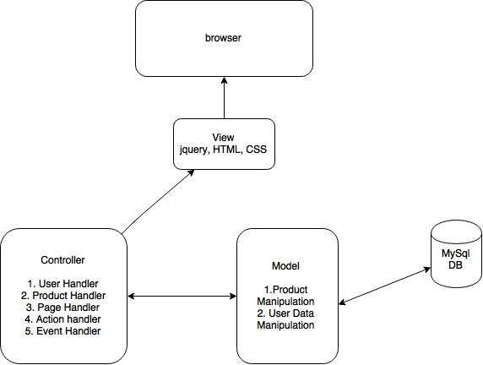

Data Flow Diagram

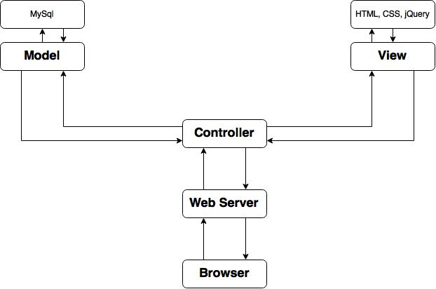

Activity Diagram

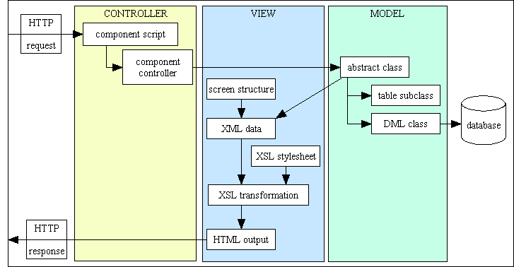

Class Diagram
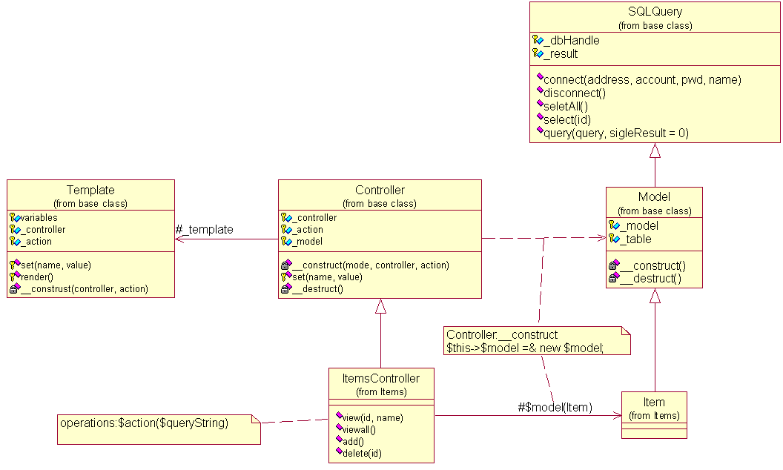

Usecase Diagram
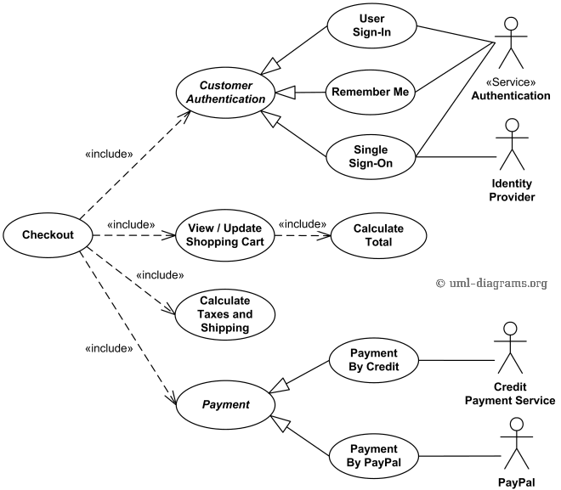

Sequence Diagram
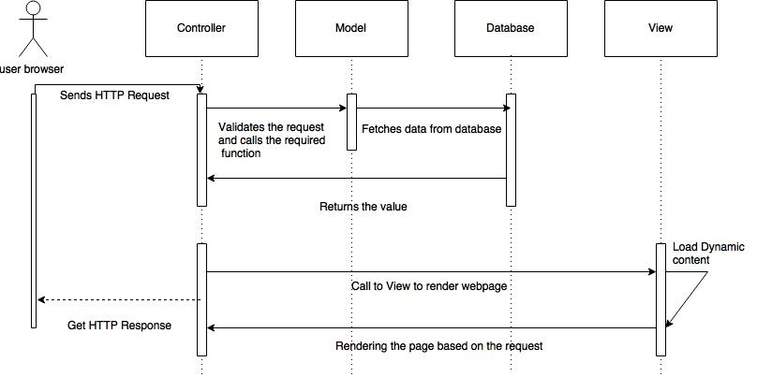

IMPLEMENTATION

MODULE DESCRIPTION

4.1.1Login and Signup API
The information about the user will be obtained by form which is then formatted in order to prevent SQL injection. The input values from the user are validated properly to ensure the protection. Random Session key is generated during each entry so that brute force attack can be stopped

4.1.2Product Manipulation
  - Categorize and display all products available
  - Filtering the products based on user needs
  - Display only the featured products or latest products

4.1.3Messaging and notification
  - Area wise notification
  - Customer retailer communication system
  - Points system for offers

4.1.4Admin Panel
- Export the data from database to excel sheet
- Get the notifications
- Display the purchased product
- Display User information
- Updating the existing product
- Inserting new product
- Deleting the existing product

4.2 SNAPSHOTS OF MODULES
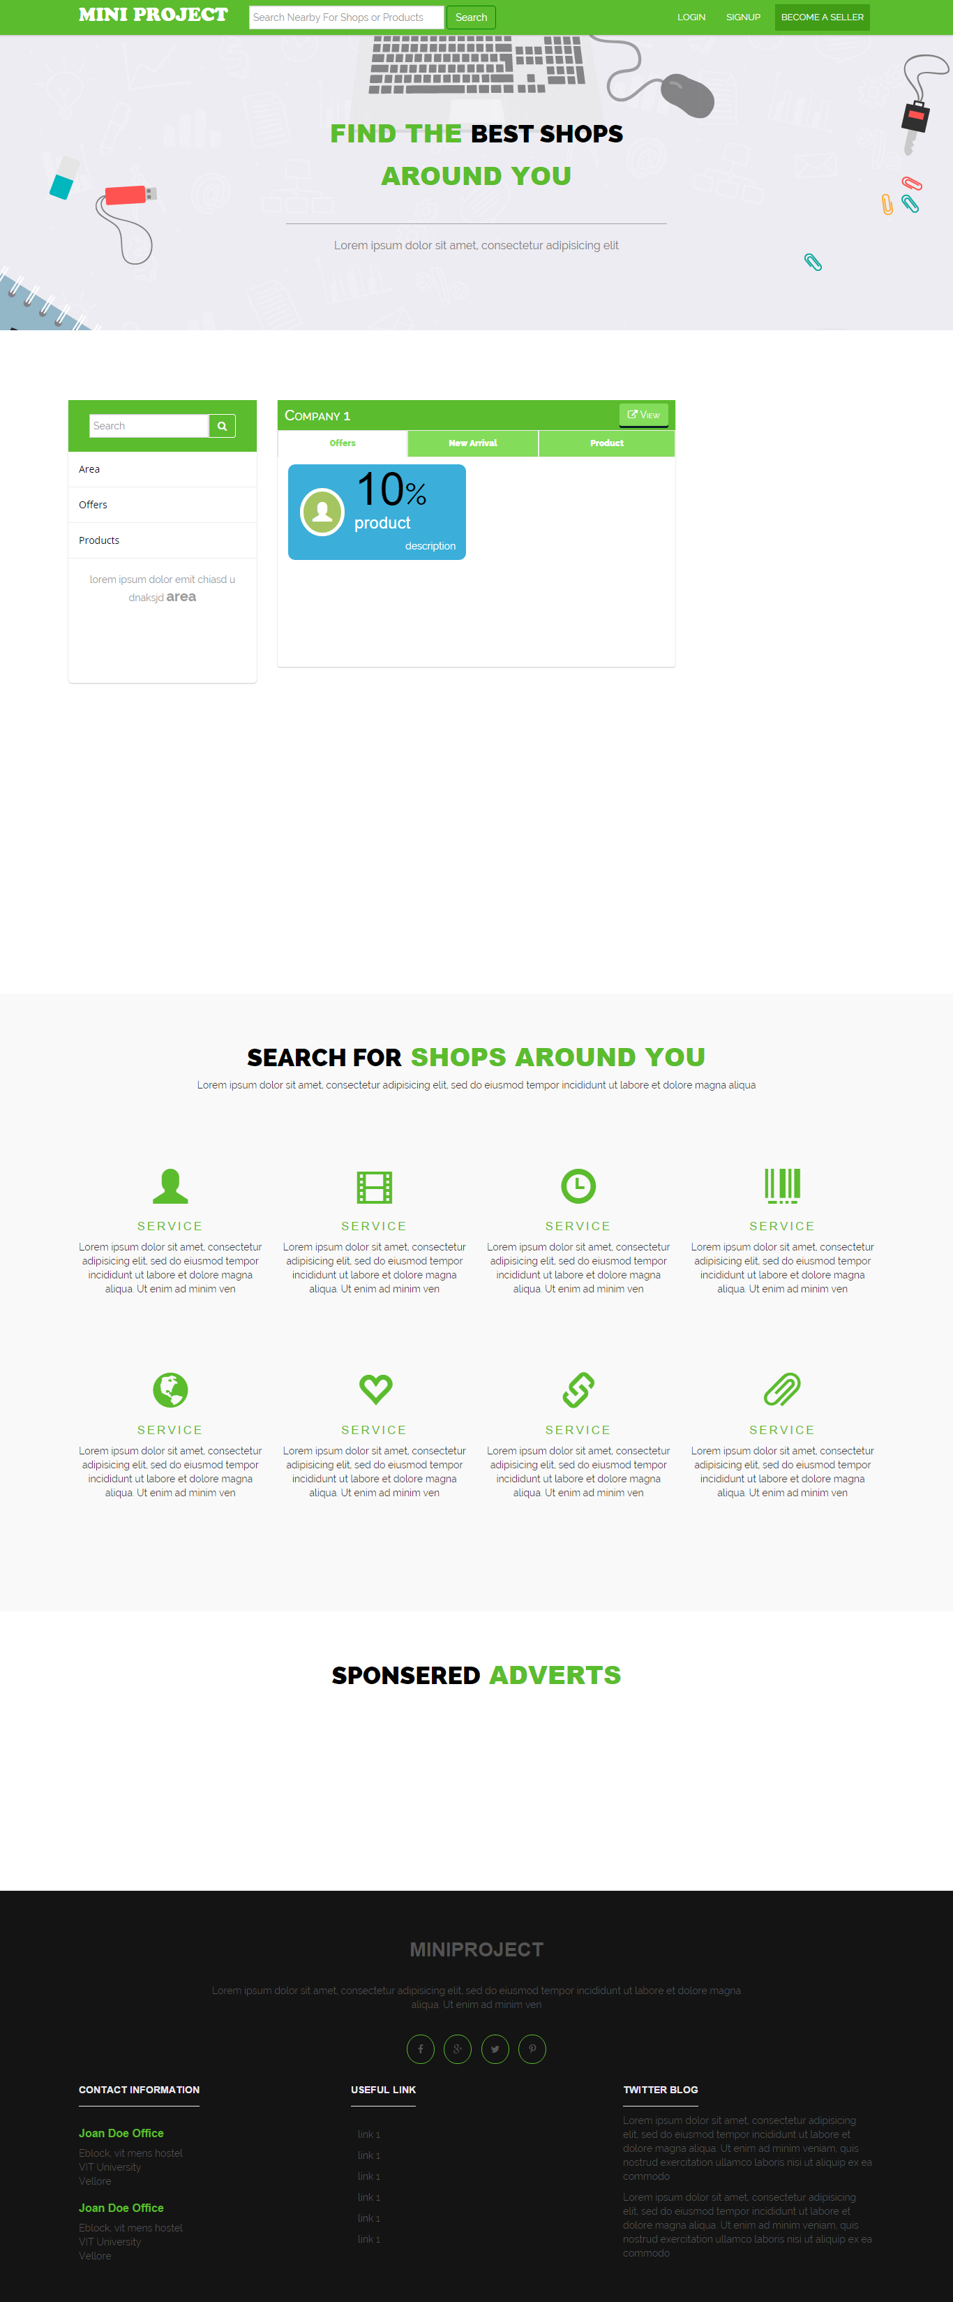

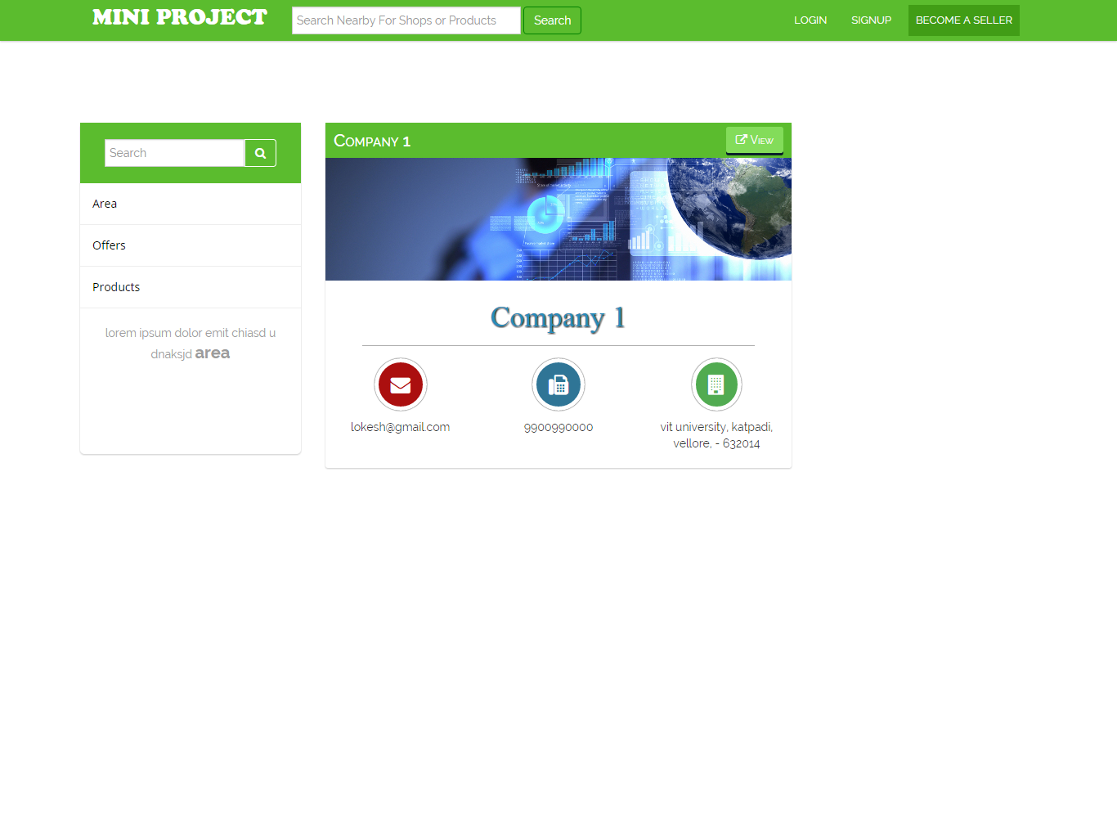

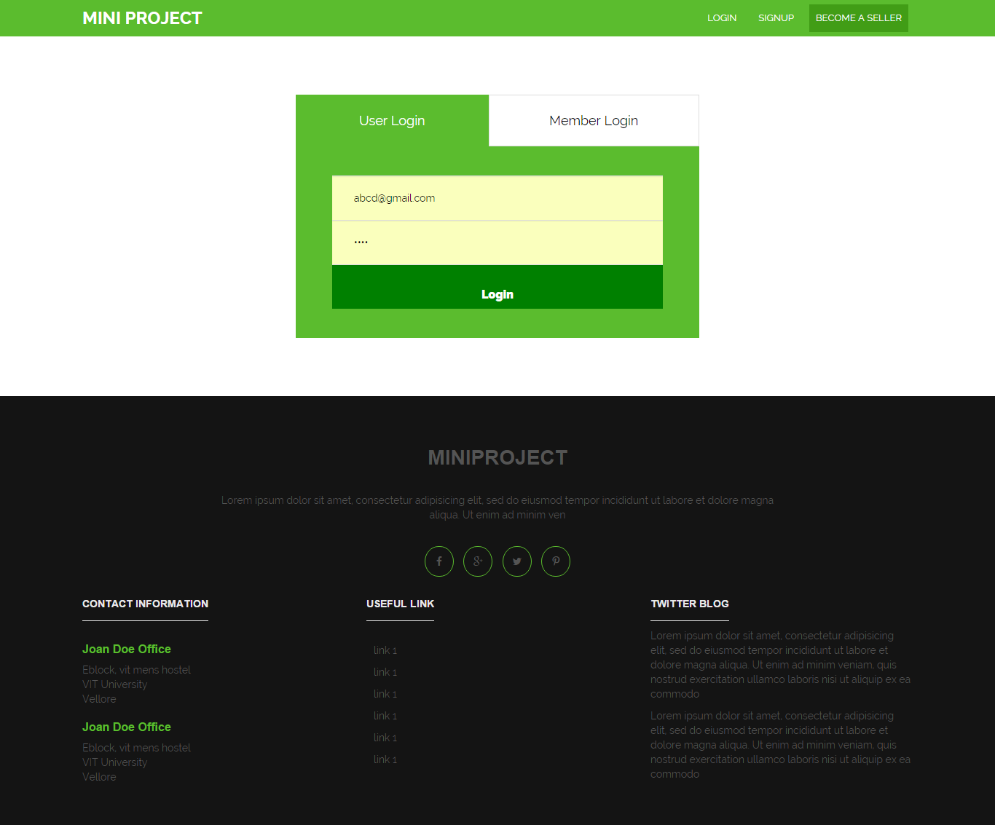

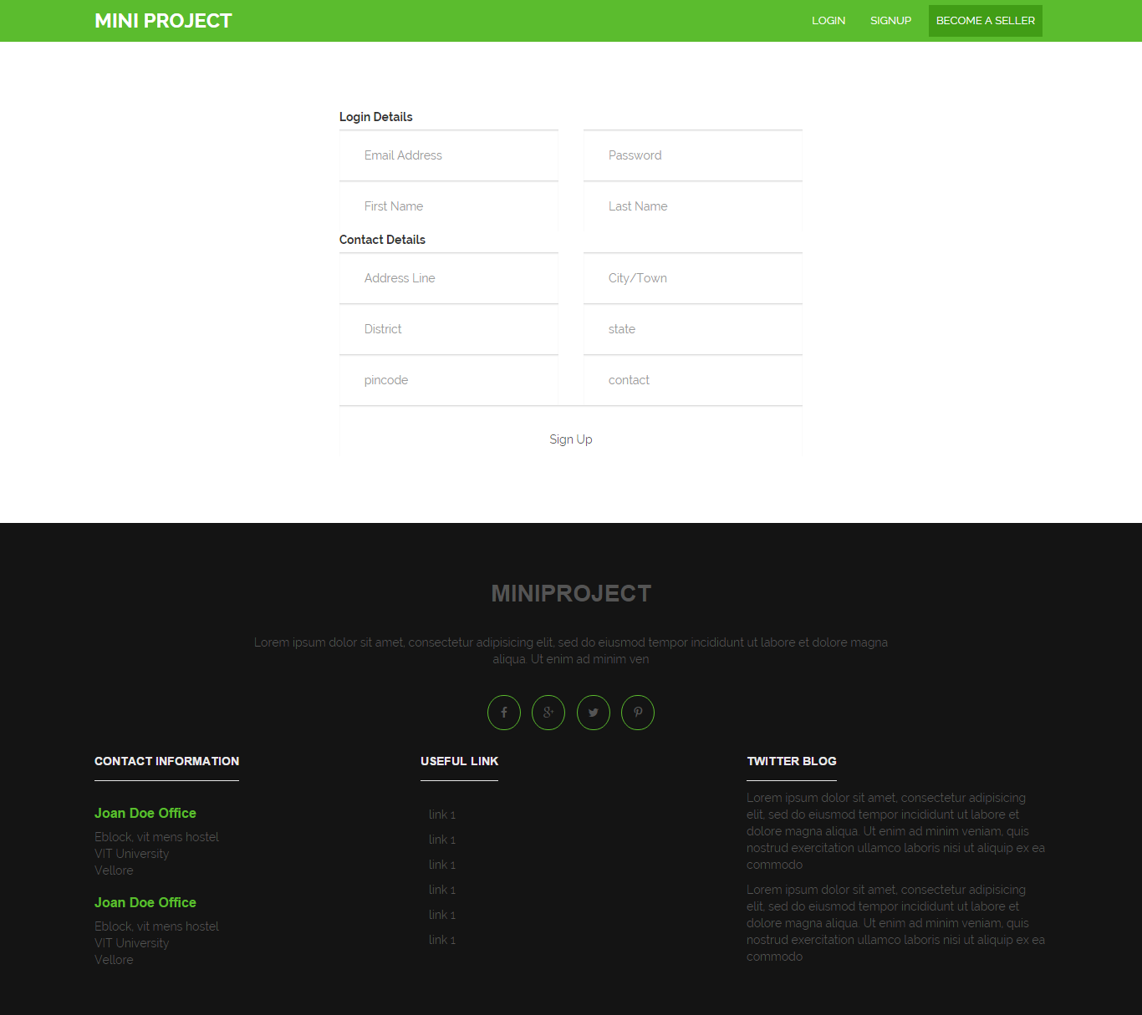

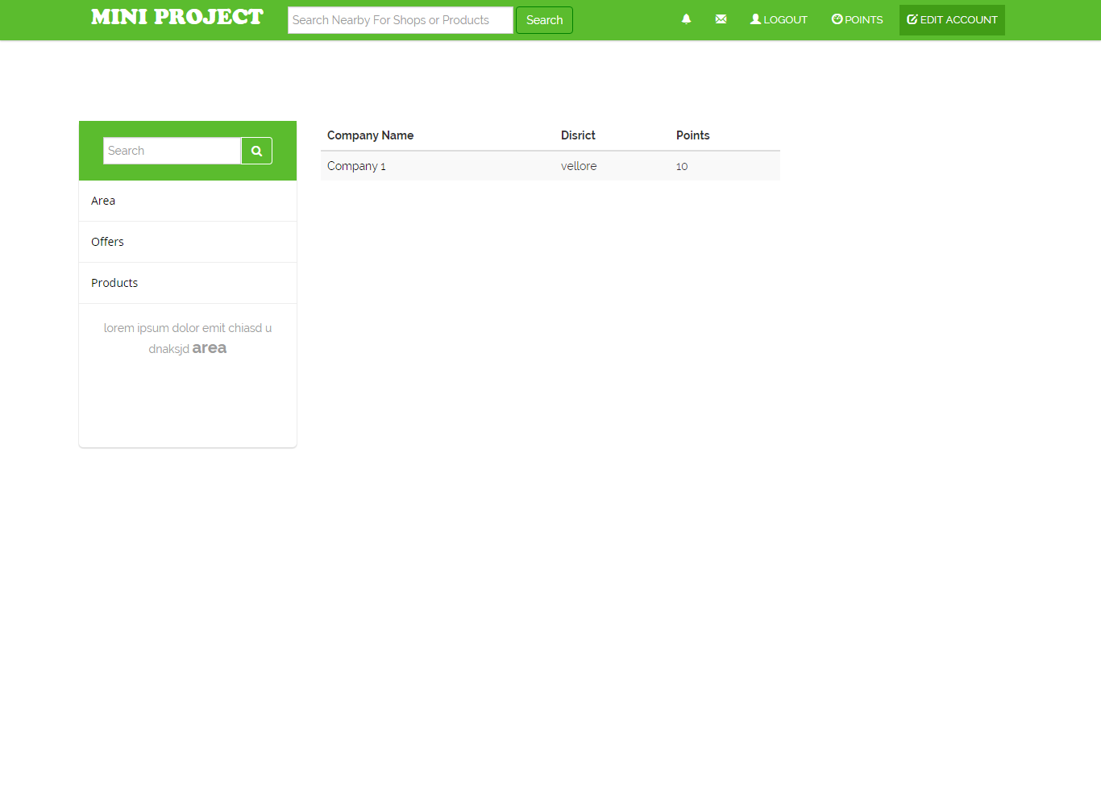



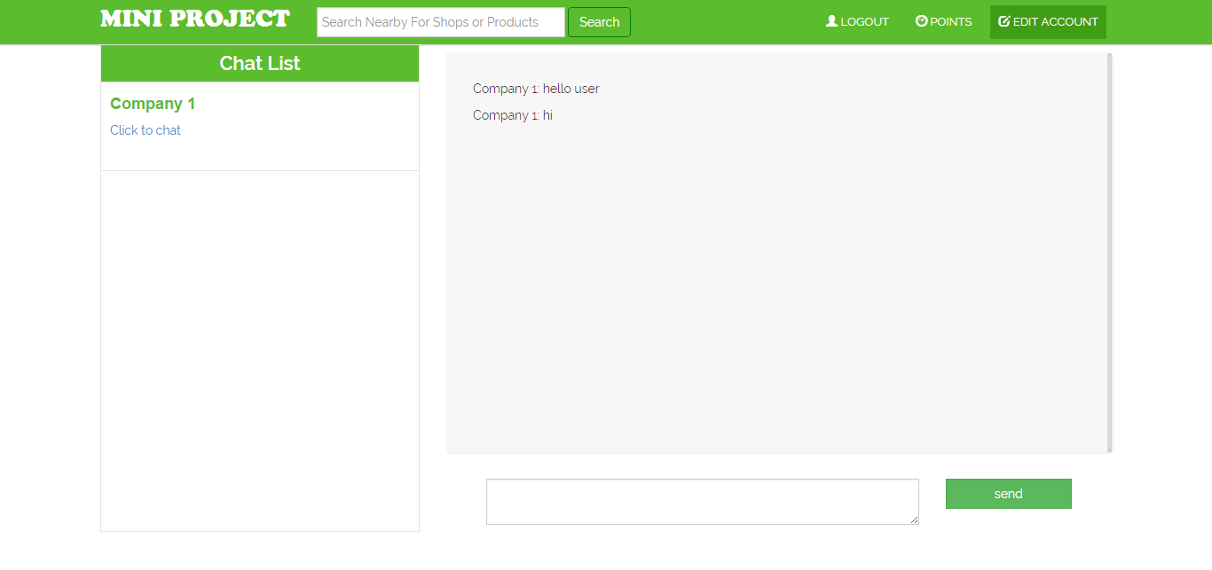

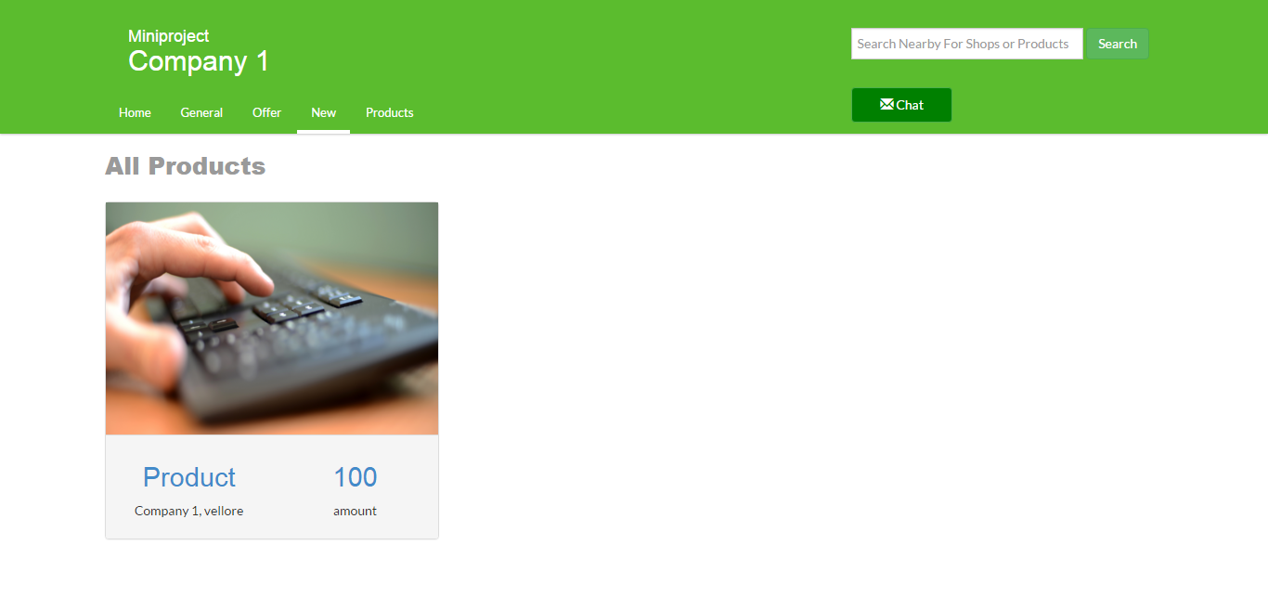

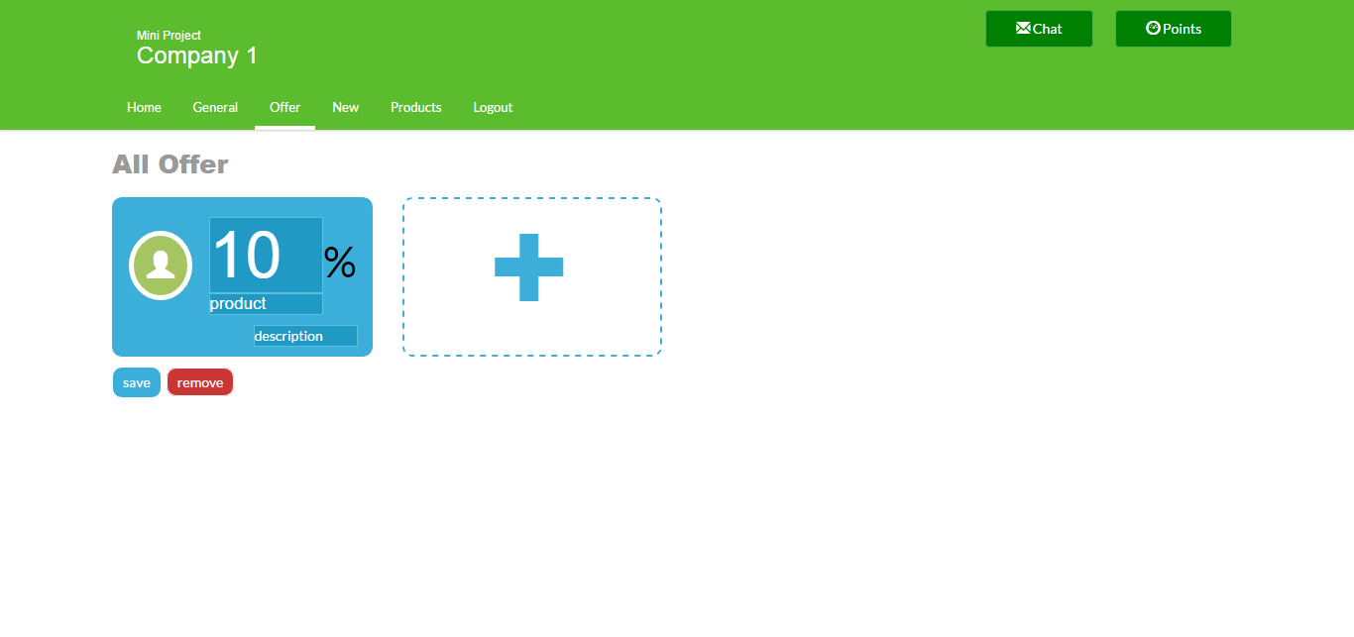

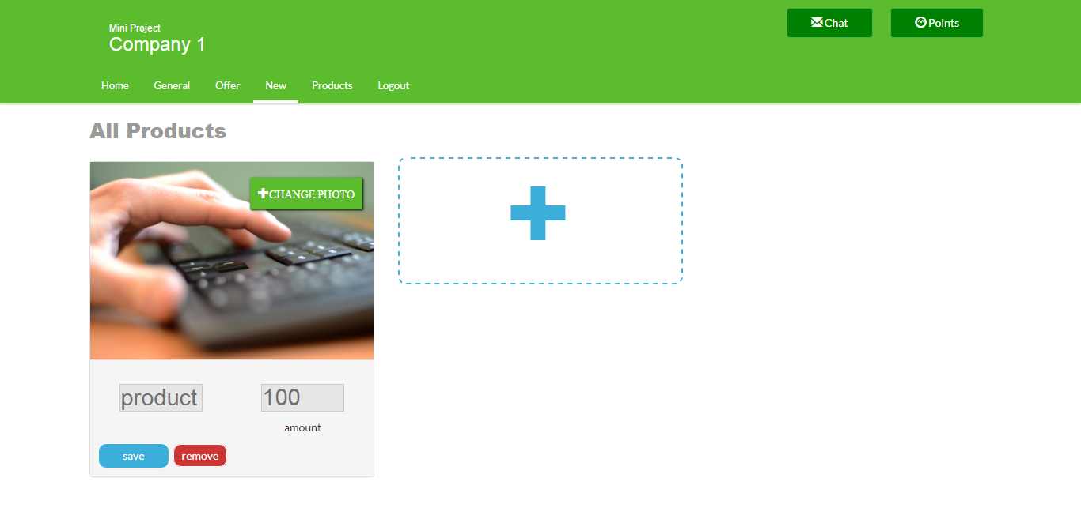

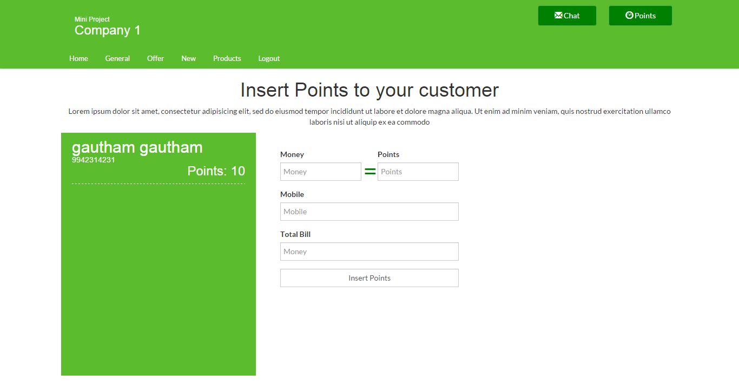

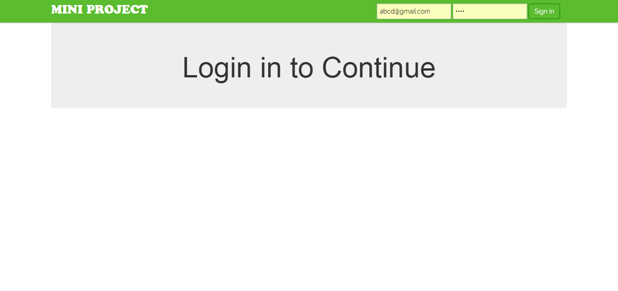

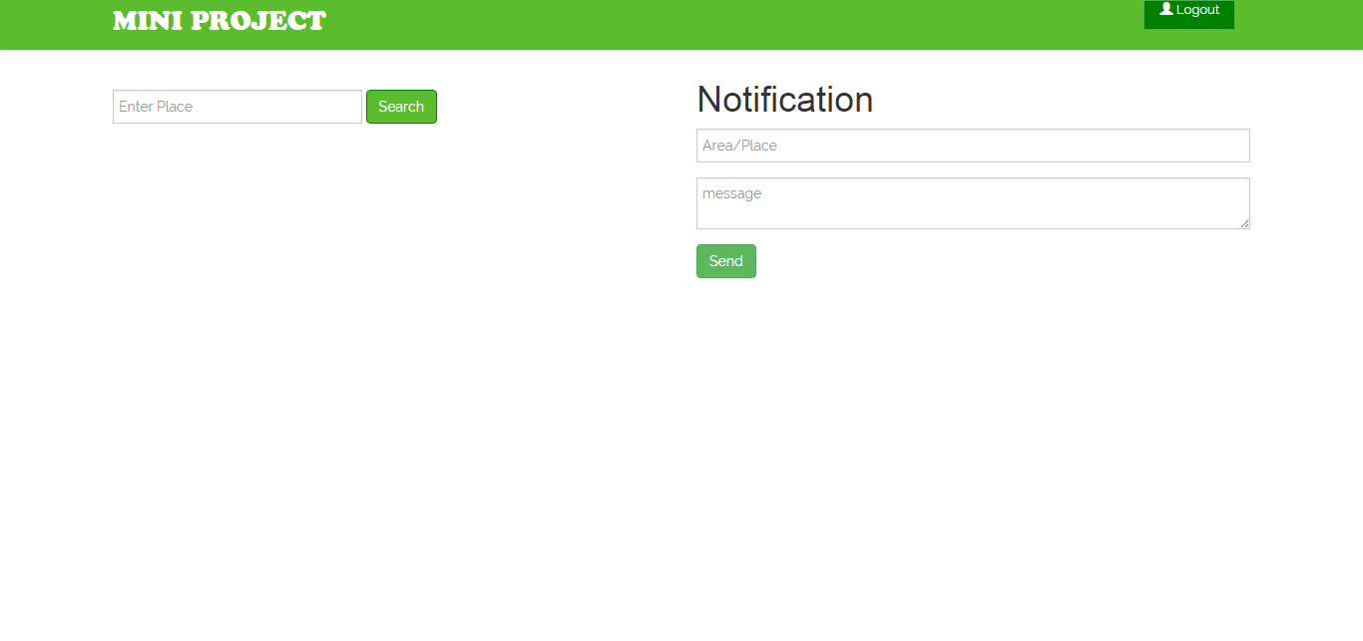

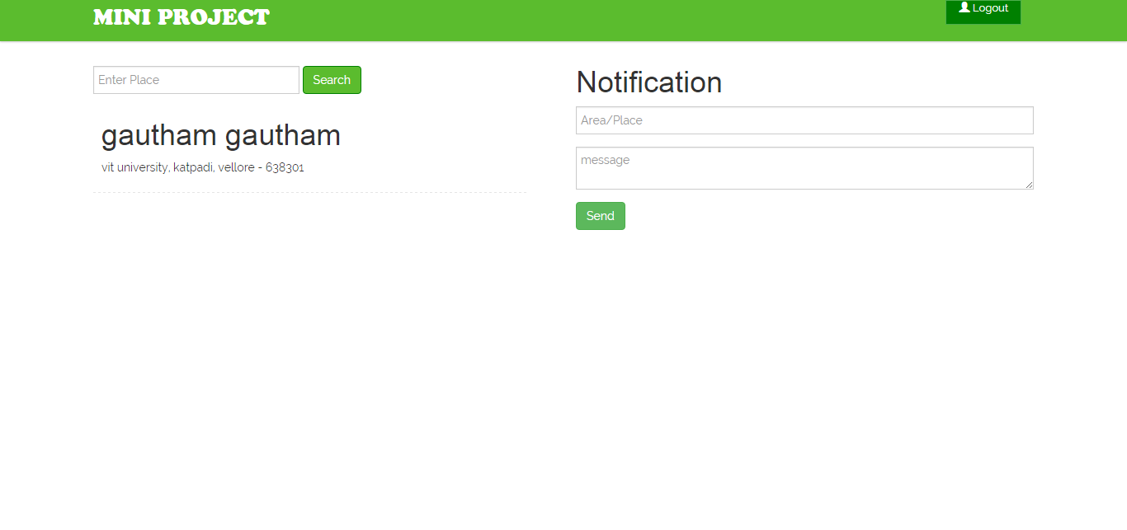

4.3 CODE

<?php

/**

*

*/

class Admin extends Controller

{

function __construct()

{

parent::__construct();

Session::init();

$this->view->msg = "";

}

public function index()

{

$this->view->render('admin/header', true);

$this->view->render('admin/index', true);

$this->view->render('admin/footer', true);

}

public function login()

{

$result = $this->model->login();

if($result == true)

{

header('Location: '.URL.'admin/dashboard');

exit();

}

else

{

Session::destroy();

$this->view->render('admin/header', true);

$this->view->render('admin/error', true);

$this->view->render('admin/footer', true);

}

}

public function dashboard()

{

$log = Session::get('admin-loggedIn');

if($log)

{

$this->view->user = "";

if(isset($_POST['place']))

{

$this->view->user = $this->model->user();

}

if(isset($_POST['area'])&&isset($_POST['message']))

{

$this->model->send();

$this->view->msg = "<p style='color: green;'>Successfully Sent!</p>";

}

$this->view->render('admin/header', true);

$this->view->render('admin/dashboard', true);

$this->view->render('admin/footer', true);

}

else

{

$this->view->render('admin/header', true);

$this->view->render('admin/error', true);

$this->view->render('admin/footer', true);

}

}

public function logout()

{

Session::destroy();

header('Location: '.URL.'admin');

}

}

<?php

/**
*
*/
class Chat extends Controller
{

function __construct()
{
parent::__construct();
Session::init();
if(Session::get('loggedIn') == true)
{
$this->role = Session::get('role');
switch ($this->role)
{
case 'user':
$this->id = Session::get('uid');
break;
case 'member':
$this->id = Session::get('cid');
break;

default:
# code...
break;
}

}
else
{
header('Location: '.URL.'login');
}
}
public function index()
{
$this->view->chatList = $this->model->chatList($this->role, $this->id);
$this->view->render('chat/header', true);
$this->view->render('chat/index', true);
$this->view->render('chat/footer', true);

}
public function id($toid)
{
$this->view->toid = $toid;
$this->view->chatList = $this->model->chatList($this->role, $this->id);
$this->view->message = $this->model->message($this->role, $this->id, $toid);
$this->view->render('chat/header', true);
$this->view->render('chat/index', true);
$this->view->render('chat/footer', true);
}
public function send()
{

$this->model->send();

}
}
<?php

/**
*
*/
class Company extends Controller
{

function __construct()
{
parent::__construct();
}
public function general($id)
{
$this->view->id = $id;
$this->view->tab = 1;
$this->view->company = $this->model->company($id);

$this->view->render('company/index');
}
public function new_products($id)
{
$this->view->id = $id;
$this->view->tab = 3;
$this->view->company = $this->model->company($id);
$this->view->products = $this->model->new_products($id);
$this->view->render('company/products');
}
public function products($id)
{
$this->view->id = $id;
$this->view->tab = 4;
$this->view->company = $this->model->company($id);
$this->view->products = $this->model->products($id);
$this->view->render('company/products');
}
public function offer($id)
{
$this->view->id = $id;
$this->view->tab = 2;
$this->view->company = $this->model->company($id);
$this->view->products = $this->model->offer($id);

$this->view->render('company/offer');
}
}
<?php

/**
*
*/
class Edit extends Controller
{

function __construct()
{
# code...
parent::__construct();
$this->view->error = "";
$this->view->success = "";
Session::init();
$role = Session::get('role');
$flag = Session::get('loggedIn');
if($role == "member" && $flag)
{
$this->view->tab = "";
}
else
{
header('Location: '.URL.'error');
}

}
public function index()
{
$this->view->tab = 1;
$this->view->company = $this->model->company();
$this->view->render('edit/header',true);
$this->view->render('edit/index',true);
$this->view->render('edit/footer',true);

}
public function upload_img($action, $pid = false)
{
$this->model->upload_img($action, $pid);

}
public function offer()
{
$this->view->tab = 2;
$this->view->offer = $this->model->getOffers();
$this->view->render('edit/header',true);
$this->view->render('edit/offer',true);
$this->view->render('edit/footer',true);
}
public function new_products()
{
$this->view->tab = 3;
$this->view->products = $this->model->getNewProducts();
$this->view->render('edit/header',true);
$this->view->render('edit/new_products',true);
$this->view->render('edit/footer',true);
}
public function products()
{
$this->view->tab = 4;
$this->view->products = $this->model->getProducts();
$this->view->render('edit/header',true);
$this->view->render('edit/products',true);
$this->view->render('edit/footer',true);
}
public function points($action = false)
{
$this->view->tab = 5;
if($action == 'add')
{
$flag = $this->model->addPoints();
if($flag == true)
{
$this->view->success = "<p style='color: green'>Successfully Updated!</p>";
}
else
{
$this->view->error = "<p style='color: red'>No User Found!</p>";
}

}
$this->view->user = $this->model->getUserPoints();
$this->view->render('edit/header',true);
$this->view->render('edit/points',true);
$this->view->render('edit/footer',true);
}
public function add($id)
{
$flag = $this->model->add($id);
if($flag == false)
{
switch($id)
{
case 1:
$this->view->tab = 2;
$this->view->error = "<p style='color: red'>Slots are Full! </p>";
$this->view->offer = $this->model->getOffers();
$this->view->render('edit/header',true);
$this->view->render('edit/offer',true);
$this->view->render('edit/footer',true);
break;
case 2:
$this->view->tab = 3;
$this->view->error = "<p style='color: red'>Slots are Full! </p>";
$this->view->products = $this->model->getNewProducts();
$this->view->render('edit/header',true);
$this->view->render('edit/new_products',true);
$this->view->render('edit/footer',true);
break;
case 3:
$this->view->tab = 3;
$this->view->error = "<p style='color: red'>Slots are Full! </p>";
$this->view->products = $this->model->getProducts();
$this->view->render('edit/header',true);
$this->view->render('edit/products',true);
$this->view->render('edit/footer',true);
break;
default: header('Location: '.URL.'error');
}
}
}
public function remove($tid, $pid)
{
$this->model->remove($tid, $pid);
}
public function update($tid)
{
$this->model->update();
switch($tid)
{
case 1:
header('Location: '.URL.'edit/offer');
break;
case 2:
header('Location: '.URL.'edit/new_products');
break;
case 3:
header('Location: '.URL.'edit/products');
break;
default: header('Location: '.URL.'error');
}
}
public function logout()
{
Session::destroy();
header('Location: '.URL);
}

}
<?php

/**
*
*/
class F extends Controller
{

function __construct()
{
# code...
parent::__construct();
}

public function product()
{

$this->view->notifications = $this->model->notifications();

$this->view->product = $this->model->product();
$this->view->render('index/header', true);
$this->view->render('f/index',true);
$this->view->render('index/footer', true);

}
public function area()
{
$this->view->notifications = $this->model->notifications();
$this->view->company = $this->model->area();
$this->view->render('index/header', true);
$this->view->render('f/area', true);
$this->view->render('index/footer', true);

}
public function offer()
{
$this->view->notifications = $this->model->notifications();
$this->view->product = $this->model->offer();
$this->view->render('index/header', true);
$this->view->render('f/offer',true);
$this->view->render('index/footer', true);

}
public function search()
{
$this->view->notifications = $this->model->notifications();
$this->view->company = $this->model->getCompany();
$this->view->products = $this->model->getProducts();
$this->view->render('index/header', true);
$this->view->render('f/search', true);
$this->view->render('index/footer', true);
}

}

<?php

/**
*
*/
class Login extends Controller
{

function __construct()
{
# code...
parent::__construct();
$this->view->error = "";

}
public function index()
{

$this->view->render('login/header', true);
$this->view->render('login/index', true);
$this->view->render('login/footer', true);

}
public function user()
{
$status = $this->model->user();

if($status)
{
header('Location: '.URL);
exit();
}
else
{
$this->view->error = "<p style='color: red;'>Login Error! Please Enter Correct Details!</p>";
$this->view->render('login/header', true);
$this->view->render('login/index', true);
$this->view->render('login/footer', true);
}
}
public function member()
{
$status = $this->model->member();
if($status)
{
header('Location: '.URL.'edit');
exit();
}
else
{
$this->view->error = "<p style='color: red;'>Login Error! Please Enter Correct Details!</p>";
$this->view->render('login/header', true);
$this->view->render('login/index', true);
$this->view->render('login/footer', true);
}
}
}

<?php

/**
*
*/
class Signup extends Controller
{

function __construct()
{
# code...
parent::__construct();
$this->view->msg = "";

}
public function user_signup()
{

$this->view->render('login/header', true);

$this->view->render('signup/user', true);
$this->view->render('login/footer', true);

}
public function member_signup()
{

$this->view->render('login/header', true);

$this->view->render('signup/member', true);
$this->view->render('login/footer', true);
}
public function run()
{
$status = $this->model->run();

if($status)
{

$this->view->msg = "<p style='color: green'>Account Registered Successfully! <a href='".URL."/login'>Login to continue</a></p>";
$this->view->render('login/header', true);

$this->view->render('signup/'.$status, true);
$this->view->render('login/footer', true);
}
else
{
$this->view->msg = "<p style='color: red'>Account Already Exist! <a href='".URL."/login'>Login to continue</a></p>";
$this->view->render('login/header', true);

$this->view->render('signup/member', true);
$this->view->render('login/footer', true);
}
}

}
<?php

/**
*
*/
class User extends Controller
{

function __construct()
{
parent::__construct();

}

public function login($uploader = false)
{
$this->model->login($uploader);

}
public function signup($uploader = false)
{

$this->model->signup($uploader);
}
public function points()
{
$this->view->points = $this->model->getPoints();
$this->view->notifications = $this->model->notifications();

$this->view->render('index/header', true);
$this->view->render('user/points', true);
$this->view->render('index/footer', true);
}
public function logout()
{
Session::init();
Session::destroy();
header('Location: '.URL);
}
}
<?php

class Bootstrap {

function __construct() {

$url = isset($_GET['url']) ? $_GET['url'] : null;
$url = rtrim($url, '/');
$url = filter_var($url, FILTER_SANITIZE_URL);
$url = explode('/', $url);

//print_r($url);

if (empty($url[0])) {
require 'controller/index.php';

$controller = new Index();
$controller->loadModel('index');
$controller->index();
return false;
}

$file = 'controller/' . $url[0] . '.php';
if (file_exists($file)) {
require $file;

} else {

$this->error();
return false;
}

$controller = new $url[0];
$controller->loadModel($url[0]);

// calling methods
if(isset($url[3]))
{
if (method_exists($controller, $url[1])) {
$controller->{$url[1]}($url[2], $url[3]);
} else {
$this->error();
}
}
else if (isset($url[2])) {
if (method_exists($controller, $url[1])) {
$controller->{$url[1]}($url[2]);
} else {
$this->error();
}
} else {
if (isset($url[1])) {
if (method_exists($controller, $url[1])) {
$controller->{$url[1]}();
} else {
$this->error();
}
} else {
$controller->index();
}
}

}

function error() {
require 'controller/error.php';
$controller = new Error();
$controller->index();
return false;
}

}

Test Case

5.1 SQL Injection
Input: 105 or 1=1
Executing Statement: SELECT * FROM Users WHERE uid = 105 or 1=1
Output: returns null
Input: 1
Executing Statement: SELECT * FROM Users WHERE uid = 1
Output: returns baskar object

5.2 Cross site scripting (XSS)
Input: window.alert(“hi”);
Output: window.alert(&amp;quot;hello&amp;quot;); (Javascript not executed)
Input:./portal/index.php?name=guest%3Cscript%3Ealert(%27attacked%27)% 3C/script%3E
Output: javascript not executed
Input: ../portal/admin/?get = 1
Output: Error 404

5.3 Secured Gateway
Input: password123
Output: 2b569beaf726dc378df9f34b0845b9d3

RESULTS AND DISCUSSIONS

In general, today’s businesses must always strive to create the next best thing that consumers will want because consumers continue to desire their products, services etc. to continuously be better, faster, and cheaper. In this world of new technology, businesses need to accommodate to the new types of consumer needs and trends because it will prove to be vital to their business’ success and survival. E-commerce is continuously progressing and is becoming more and more important to businesses as technology continues to advance and is something that should be taken advantage of and implemented.
From the inception of the Internet and e-commerce, the possibilities have become endless for both businesses and consumers. Creating more opportunities for profit and advancements for businesses, while creating more options for consumers. However, just like anything else, e-commerce has its disadvantages including consumer uncertainties, but nothing that can not be resolved or avoided by good decision-making and business practices.
There are several factors and variables that need to be considered and decided upon when starting an e-commerce business. Some of these include: types of e-commerce, marketing strategies, and countless more. If the correct methods and practices are followed, a business will prosper in an e-commerce setting with much success and profitability.

CONCLUSION AND FUTURE WORK

Ecommerce portals are extremely popular methods to promote brands and businesses. The Ecommerce portal offers an online storefront that is completely customizable. It helps sell products to a global marketplace with taxes, duty, discounts, and shipping costs automatically calculated. A great feature of an Ecommerce portal is it allows easy management of multiple promotion and discounting schemes. Ecommerce web portal owners can completely manage their online store via the Admin panel, a web-based management area. Another advantage is that the Ecommerce portal allows the sale of numerous products with intelligent merchandising tools such as cross-selling, promotions, and automated e-mail. Ecommerce portal owners can manage visitors to the site - keep track of who's on the site and what they are doing. The portals even deliver features such as the ability to manage the shopping basket - keep track of who wants to buy what. Service provider and retailers can manage customers - handle the conversion from 'visitor' to 'customer', along with all the order capture information.

REFERENCES

- Gamrat B., "PHP and preprocessed Web pages," Dr.Dobb'S Journal, January 2006, 31(1), pp. 46-48
- Stig Saether Bakken, Alexander Aublach, Egnn Schmid et al, "PHP Manual," The PHP Documentation Group, 2007.
- Hofmeister C., Nord R.L., Soni D., "Applied Software Architecture,". Addison Wesley. 2000.
- Song Wei, "Approach to Web application program based on MVC and J2EE," Hebei Journal of Industrial Science&Technology,July 2005,22(4),pp. 189-191
- Hasin Hayder, J.P.Maia, L.Gheorge, "Smarty PHP Template Programming And Applications," Packt Publishing, 2006, pp. 23-33
- Smarty - the compiling PHP template engine [EB/OL]. http://smarty.php. net/manual/en/, 2006,5.
- Veglis A., Leclercq M., Quema V., "PHP and SQL made simple, Distributed Systems Online," Aug 2005, 6(8),pp. 15-22

